®γσ, ENG LIAN HU
Personal Profile
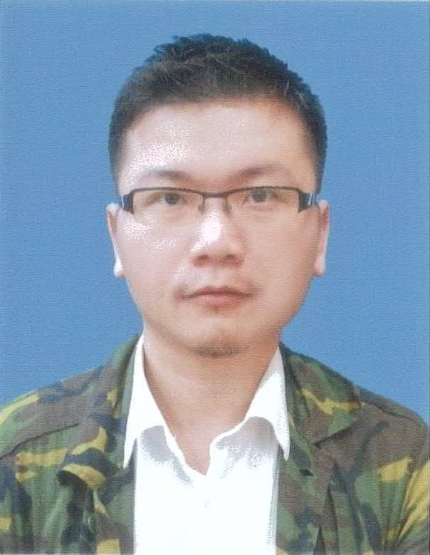
®γσ, Lian Hu 白戸則道®
10/22/1984

Curriculum Vitae

, Eng Lian Hu

1. About Me
Title | Details
Date of Birth | 1984-10-22
Age | 33y 0m 19d
Malaysian Phone Number | +6-017-2100905
Taiwanese Phone Number | +886-098-910-4576
Home Land-line Contact | +6-03-89570938
Email Address | englianhu@gmail.com
Home Town | 290 Kampung Tiram Buruk, 45500 Tanjong Karang, Selangor, Malaysia
Nationality | Malaysian
Religion | Buddha

2. Education
Apr-2014 to May-2016 : Professional Certificate, Specialization Data Science; (Cousera - Johns Hopkins University (JHU) )
- 01 Course title : The Data Scientist’s Toolbox
- 02 Course title : R Programming
- 03 Course title : Getting and Cleaning Data
- 04 Course title : Exploratory Data Analysis
- 05 Course title : Reproducible Research
- 06 Course title : Statistical Inference
- 07 Course title : Regression Models
- 08 Course title : Practical Machine Learning
- 09 Course title : Developing Data Products
- 10 Course title : Data Science Capstone
- Data Science Specialization

Jun-2015 to Aug-2015 : Professional Certificate, Specialization Data Science; (Cousera - University of Michigan (UM))
- Course title : Programming for Everybody (Python)

Mar-2002 to Dec-2003 : Professional Certificate, Japanese Language Profeciency Test; (JLPT - Japan Foundation Kuala Lumpur and Japan Educational Exchanges and Services )
- Course title : Japanese Language Profeciency Test - Level III

3. Experience
Aug-2017 to Present : Unemployment
- Availability : Immediately

May-2016 to Dec-2016 : Customer Service Executive;(employed by Manpower Human Resource Sdn Bhd and deployed by Mindpearl )
- Job Task : A customer service executive in Mindpearl but handle Malaysia Airlines customers, need to handle Malaysia Airlines customers. General enquiry, new booking, booking amendment.

Oct-2015 to Jan-2016 : Online Gaming, Sportsbook Trader; (employed by Global Solution Sdn Bhd)
- Job Task : Follow (Back) sportsbook punters’ bets, hedging and oppose (Lay) pathological gamblers, doing deposit transactions for China mainland customers.

May-2015 to Sep-2015 : Online Gaming, Customer Service; (employed by OneMedia Sdn Bhd)
- Job Task : Handling inbound and outbound calls, livechat, feedback, all deposit and withdrawal transactions.

Feb-2015 to Apr-2015 : Online Retails, Fraud Prevention; (employed by IdealSeed Sdn Bhd and deployed by Apple Inc. )
- Job Task : Handling inbound and outbound calls, check and approve/reject customers’ ordered transactions.

Mar-2014 to Apr-2014 : Customer Service Executive; (employed by FujiXerox )
- Job Task : Handling inbound calls from Taiwanese customers’ orders and printer maintenance.

Nov-2013 to Mar-2014 : Online Gaming Trading, Team Leader/Trader; ( employed by SBSolutionCorp Ltd )
- Job Task : Handling few members to update scores and bets settlement.

Nov-2012 to May-2013 : TV Broadcasting Channel, Video Editor; (employed by U-Drive Media Sdn Bhd )
- Job Task : Watching and filtering video streaming from abroad prior to play in our country. TM Bhd Telekom Malaysia project

Mar-2008 to Jul-2012 : Outsourcing Business, Customer Service; (employed by Scicom (MSC) Bhd )
- Job Task : Handling inbound and outbound calls, livechat, feedback, all deposit, withdrawal and also phone bets’ transactions. Sometimes need to do translation and also analysis job tasks. Ladbrokes PLC’s project
- Awarded Customer Service Workshop
- Awarded (Ladbrokes) Appreciation Certificate.jpg

Jul-2006 to Jun-2007 : Online Gambling, Trainer/Trader; (employed by Caspo Inc. )
- Job Task : Provides training to newbies on sportsbook trading and live scout. Need to backup for trading as well. Sometimes need to do translation and also analysis job tasks.

Nov-2005 to Jul-2006 : Online Gambling, Team Leader/Senior Trader; (employed by Telebiz Sdn Bhd )
- Job Task : Provides training to newbies on sportsbook trading purchasing stocks, need to update scores for bets financial settlement. Handle live-matches on corners. Sometimes need to do translation and also analysis job tasks.

4. Technical Experience
Analysing Financial Report of Bookmakers
- Analyse the financial report and stock price of gambling public listed company.
- Analyse the profit and loss of Singbet and Singbet2.
- Kindly click here for more information.

binary.com Technical Assessment
- Financial betting products modelling and also betting strategy.
- Application of Arima, Exponential Smoothing model, and various Garch models for prediction and Kelly model for investment.
- Kindly click here for more information.

Betting Strategy and Model Validation
- Using Selenium to gather soccer matches data via webdriver Phantomjs.
- Natural language analysis on the scrapped livescore data to match the team names from firm A for automation soccer team name matching.
- Application of different leverage of Kelly criterion for staking.
- Kindly click here for more information.

Introducing ®Studio Server for Data Scientists
- An tutorial for setup RStudio server and shiny server on Linux CentOS 7.
- Kindly click here for more information.

Testing Inefficiency of Sports-Bookmakers by Kelly Model
- *Apply dynamic weighted diagonal inflated bivariate poisson model to the scrapped data from- **WebDriver Dynamic Webpage Scrapping- to build an prediction model.*
- Application of Kelly criterion model to betting on 10 sportsbookmakers in year 2011/12 and 2012/13.
- Kindly click here for more information.

Dixon-Coles1996
- Dixon & Coles 1996 soccer scores modelling.
- Kindly click here for more information.

WebDriver Dynamic Webpage Scrapping
- Application of RSelenium and Python to scrape the odds price of sportbookmakers and also livescore data from 7M and NowGoal website as well as filter the odds price data.
- Kindly click here for more information.

Soccer League Web Scraping
- Static webpage soccer scores scraping.
- Kindly click here for more information.

Odds Modelling and Testing Inefficiency of Sports-Bookmakers
- Collect the livescore and also 1x2, Asian Handicap, Over Under odds price data of 29 sportsbookmakers manually from 500WAN, BET007 and NowGoal website and filter the odds price data from 2006 to 2011.
- Apply dynamical weighted diagonal inflated bivariate Poisson model in R to test the return of the investment.
- Kindly click here for more information.

Apply Poisson regression on sports odds modelling
- Application of Poison model onto soccer sports odds modelling.
- Kindly click on Calculator.xls and Statistics (ver3).xls for the research.

5. Skill
Skill and Expertise
Skill and Expertise Rating Level (from newbie 1 to expert 10)

6. Other/Miscellaneous
I am currently learn to setup own sportsbook hedge fund company Scibrokes® which will be the first professional sportsbook hedge fund in Asia I though. You are welcome to own yours by refer to my 安装 ®StudioとShiny服务器 . You are welcome to contact me at englianhu@gmail.com.

7. Social Network

Appendices

8. Documenting File Creation
It’s useful to record some information about how your file was created.
- File creation date: 2015-10-12
- R version 3.4.2 (2017-09-28)
- R version (short form): 3.4.2
- rmarkdown package version: 1.6.0.9009
- File version: 1.0.1
- File latest updated date: 2017-11-10
- Author Profile: ®γσ, Eng Lian Hu
- GitHub: Source Code
- Additional session information
[1] “2017-11-10 16:16:35 JST” 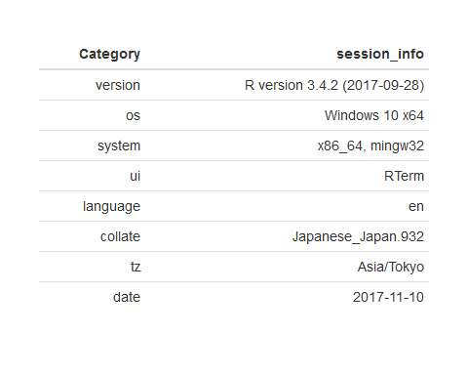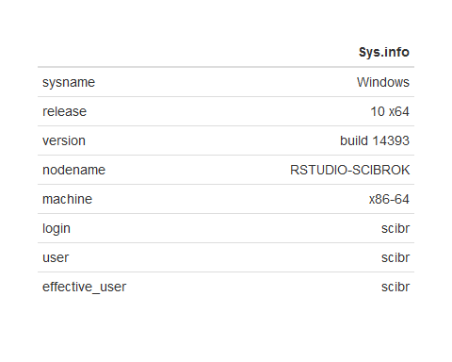

9. References
- You are feel free to create your own CV by R Markdown V2 by refer to Document Templates
- rticles package version: 0.4.1
- Pandoc Markdown
- You can plot a timeline graph or load the timeline package.
- Here I apply googleVis package to plot the animated graph. You are feel free to browse over the vignettes for more examples.
- You can also modify the layout of website by referring Top Five CSS Customizations for R Presentations.
- There are a lot of diversified symbols I get from Greek Alphabet Symbols

Powered by - Copyright© Intellectual Property Rights of Scibrokes®個人の経営企業

? The website not yet setup but now keep up learning.

